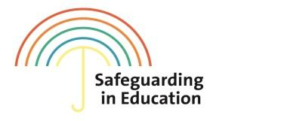

**COVID- 19 – Interim Safeguarding Guidance**

**Addendum to the Safeguarding/Child Protection Policy**

This document has been developed to reflect changes in practice as a result of the COVID -19 (Coronavirus) outbreak on a local level. Elements of the document have been amended to reflect local arrangements at SETTING NAME.

**It is important that all staff and volunteers are aware of the new policy and are kept up to date as it is revised. The revised policy should continue to be made available publicly.**

**Setting Name:**

**Policy owner:**

**Date:**

**Date shared with staff:**

Contents:

1. Background……………………………………………………………………………………………………………………………….2
2. What staff and volunteers should do if they have any concerns about a learner……………………..2
3. Designated Safeguarding Lead (and deputy) arrangements: including First Aid cover………….…..3
4. Cluster working…………………………………………………………………………………………………………………………5
5. Local updates: received from the local 3 safeguarding partners……………………………………………….6
6. Supporting vulnerable learners (including in the event a setting is closed)……………………………...7
7. Identifying and responding to peer on peer abuse …………………………………………………………………10
8. Keeping safe online : virtual learning and using social media to communicate with learners..10
9. What to do if you have concerns about a staff member or volunteer who may pose a safeguarding risk to learners………………………………………………………………………………………..…………11

Appendix A – Check-ins/Monitoring welfare of vulnerable students - hints and tips ………………………12

Appendix B – Flow chart of what to do if a child with a social worker does not attend …………………..13

Appendix C – Flow chart of what to do if a Child in Care does not attend…………………..……………………14

Appendix D – List of resources…………………………………………………………………………………………………………14

# Background

This guidance is has been developed to consider and reflect changes in line with government guidance and local arrangements as a result of the COVID-19 pandemic.

This guidance is relevant to all schools including: maintained, non-maintained, independent, academies, academy trusts, free schools, alternative provision academies, maintained nursery schools and pupil referral units.

Where the guidance refers to ‘colleges’ this includes all of the following: further education colleges, sixth-form colleges, institutions designated as being in the further education sector, other further education providers, funded by the Education and Skills Funding Agency, such as 16 to 19 academies and independent learning providers, including special post-16 institutions.

Practice should reflect statutory guidance Keeping Children Safe in Education (KCSIE) 2019 and settings should continue to have regard to their legislative duty.

The government is preparing legislation to suspend or modify some requirements of schools to enable them to focus on the new arrangements. Schools should focus on safeguarding duties as a priority. Where schools and trusts have concerns about the impact of staff absence – such as their Designated Safeguarding Lead (DSL) or first aiders – they should discuss immediately with the local authority (see further details below) or trust ([Coronavirus (COVID-19): school closures](https://www.gov.uk/government/publications/covid-19-school-closures)).

A full list of up to date government guidance around education settings can be found here - [Coronavirus (COVID-19): guidance for schools and other educational settings](https://www.gov.uk/government/collections/coronavirus-covid-19-guidance-for-schools-and-other-educational-settings).

# What staff and volunteers should do if they have any concerns about a learner

The way this setting is currently operating in response to concerns about the welfare of a learner, during the COVID – 19 outbreak, is fundamentally the same:

* With regard to safeguarding, the best interests of learners must always continue to come first.
* If anyone in a school or college has a safeguarding concern about any learner they should continue to act immediately.
* A DSL or deputy DSL should be available.
* It is essential that unsuitable people are not allowed to enter the children’s workforce and/or gain access to learners.
* Learners should continue to be protected when they are online.

It would be advantageous that staff and volunteers to remind themselves of what they need to look out for by reading [Part 1 of KCSIE 2019](https://assets.publishing.service.gov.uk/government/uploads/system/uploads/attachment_data/file/836144/Keeping_children_safe_in_education_part_1_2019.pdf).

## Raising a concern:

All staff and volunteers should read the next section regarding the Designated Safeguarding Lead (and deputies) to know who to speak to if you have identified a concern. You should follow the usual reporting mechanisms if you continue to work in SETTING.

As a mechanism to support safeguarding processes, temporary ‘cause for concern’ sheets are available for any new or temporary staff/volunteers who have been redeployed (or if you are supporting a learner who does not ordinarily attend your setting). A template is available from  [Record Keeping Guidance for Pupil Safeguarding/ Child Protection Files (KBSP)](https://bristolsafeguarding.org/media/xfqlqjdr/final-safeguarding-files-policy-document.docx)

The ‘cause for concern’ sheets will be scanned on to the learner’s Safeguarding/Child Protection File by the DSL/Deputy DSL or sent to the DSL at the learner’s original setting if they have been offered a temporary placement.

All staff and volunteers should act immediately to respond to a safeguarding concern. If a DSL or Deputy DSL is not available for advice, all staff should be aware of the role of the following teams **in emergency situations:**

|  |  |
| --- | --- |
| **If a child is at immediate risk call the POLICE** | **The POLICE 999** |
| **To make an URGENT referral, i.e. a child is likely to suffer or is suffering significant harm, call First Response** | **FIRST RESPONSE**  **0117 9036444**  **(Out of Hours Emergency Duty Team 01454 615 165)** |
| **To make a NON-URGENT referral, contact FIRST RESPONSE using the online form (must have parental/carer consent).** | **FIRST RESPONSE Online form**  <https://www.bristol.gov.uk/social-care-health/make-a-referral-to-first-response> |
| **To raise concerns and ask for advice about radicalisation (also contact First Response).** | **PREVENT DUTY**  **01278 647466**  [PreventSW@avonandsomerset.police.uk](mailto:PreventSW@avonandsomerset.police.uk) |
| **For advice and guidance about whether to make a referral.** | **Families in Focus (N)  0117 3521499**  **Families in Focus (E/C)  0117 3576460**  **Families in Focus (S)  0117 9037770** |

**Make sure there is a record of your actions, who you spoke to and what the agreed plan of action was. Notify the setting’s DSL/Deputy DSL as soon as possible.**

# 

# Designated Safeguarding Lead (DSL) (and Deputy) arrangements

All staff and volunteers need to know who the Designated Safeguarding Lead (DSL) and Deputy DSLs are in the setting.

* It is optimum practice to have a DSL/Deputy DSL on site at all times.
* If the DSL/ Deputy DSL is working from home they will be contactable by phone. These contact details have been made accessible to all at the setting.
* It is acknowledged that DSL training is very unlikely to take place during this period (although the option of online training can be explored). For the period COVID-19 measures are in place, a DSL (or Deputy DSL) who has been trained will continue to be classed as a trained DSL (or Deputy DSL) even if they miss their refresher training.
* The [Education Safeguarding Contacts Poster](https://drive.google.com/open?id=1dHv84YmMiaS63AzvH_OhYqOclCbN_dP5) has been made accessible by displaying it in spaces that are being used by staff and volunteers.

In the event that the DSL / Deputy DSL is not at work and uncontactable, SETTING has a contingency plan. This plan involves working in partnership, as part of a cluster, with the following settings:

|  |  |  |
| --- | --- | --- |
| Partner/ cluster DSL/ Deputy DSL contacts during COVID 19 pandemic. | | |
| Name | Title/ Name of setting | Contact details (Telephone, out of office telephone, email) |
|  |  |  |
|  |  |  |
|  |  |  |

**SETTING will notify the** [safeguardingineducationteam@brsistol.gov.uk](mailto:safeguardingineducationteam@brsistol.gov.uk) **if a change in DSL/Deputy has been made. This is to ensure the LA can support colleagues with the continuity around safeguarding learners.**

# **Cluster working**

Arrangements are likely to be fluid and require flexibility. This could include recruitment/ redeployment of teaching/ support staff or supporting students from a partner setting. There are some basic considerations that SETTING will take to ensure compliance with statutory guidance:

When working in partnership with other settings we will consider the following principles:

**Children moving schools and colleges:**

* If the vulnerable learner is on roll at SETTING, the DSL/ Deputy DSL/SENCO/ or appropriate staff will share relevant safeguarding information with relevant staff at the temporary setting to ensure that their welfare and safety is promoted.
* When a safeguarding concern is identified in either setting, there are clear processes in place to share this information and agreement about what actions are to be taken by which staff and where this is recorded. This sharing of information should be undertaken by the DSL/Deputy DSL – however if not, a member of the Senior Leadership Team (SLT) will take responsibility. SETTING will also liaise with relevant lead professionals (social care/ the HOPE virtual school).
* If the vulnerable learner has temporarily moved setting, key professionals are informed.
* As a minimum the information shared will include the learner’s risk assessment and any other key plans/ documents (where applicable) such as the; vulnerable child’s EHC plan, child in need plan, child protection plan and contact details for the Social Worker or, for Children in Care, their personal education plan should be included. If transport is a barrier for learners with a Social Worker, travel arrangements will be considered in consultation with key professionals including the Social Worker (where applicable) and parents.
* Safeguarding Police notifications are retained at SETTING, but knowledge of the notification and some content may be verbally shared, on a need to know basis, with any alternative settings to promote the student’s safety and welfare. Information about who this information is shared with will be recorded on the child’s safeguarding file as part of the notification action plan.

**Movement of staff**

* If a member of staff has been redeployed to SETTING, the DSL will consider the need for safeguarding training. As a minimum they will have a copy of SETTING’S child protection/safeguarding policy and confirmation of local processes, and DSL arrangements.
* SETTING will ensure appropriate checks have been made against that member of staff.
* For those who already hold an Enhanced DBS check, there is no expectation that a new DBS check should be obtained if that member of the workforce temporarily moves to another school or college. SETTING will seek assurance from the current employer rather than requiring new checks. This will be recorded on the Single Central Record.
* If the member of staff is filling in duties to support with First Aid or DSL cover, that member of staff will sign to say that they have read the setting’s code of conduct to enable access to relevant recording platforms (First Aid book, CPOMS, other relevant files). This will be recorded on the Single Central Record.

**Recruitment of new staff/volunteers**

* Where new staff are recruited, or new volunteers enter SETTING, they will be provided with a safeguarding induction. This will include reading the up to date Child Protection/Safeguarding Policy and [part 1 of KCSIE 2019](https://assets.publishing.service.gov.uk/government/uploads/system/uploads/attachment_data/file/836144/Keeping_children_safe_in_education_part_1_2019.pdf).
* Where SETTING is utilising volunteers, we will continue to follow the checking and risk assessment process as set out in [s.167 to s.172 of KCSIE 2019](https://assets.publishing.service.gov.uk/government/uploads/system/uploads/attachment_data/file/835733/Keeping_children_safe_in_education_2019.pdf).
* If the new member of staff or volunteer requires a new [DBS check – there has been new guidance issued](https://www.gov.uk/government/news/covid-19-changes-to-dbs-id-checking-guidelines), ID documents will be viewed over video link and scanned images will be used in advance of the DBS check being submitted.

Please seek further advice from the [Safeguarding in Education Team](https://drive.google.com/open?id=1YDfLdgw1j3eTDCDAvgx7O8VUWzYmzpoO) if needed.

## First Aid cover:

SETTING has considered additional measures to cover first aid, these may include:

* Online training may be considered where face to face training is unavailable.
* Working within a cluster to ensure a trained First Aider will be onsite.
* All staff are reminded of the setting’s procedures in responding, recording and reporting health and safety incidents. First Aid incidents will continue to be recorded and reported as per the setting’s policy. In an emergency staff and volunteers are reminded that they can call ‘111’ or ‘999’ if they are worried or concerned. Parents/Carers will be notified at the earliest convenience if there is a medical/health incident.
* Where a learner requires the administration of medication an individual risk assessment has been undertaken and this is regularly reviewed.

|  |  |  |
| --- | --- | --- |
| Partner/ Cluster First Aid cover during COVID-19 pandemic. | | |
| Name | Title/Name of Setting | Contacts (telephone number) |
|  |  |  |
|  |  |  |
|  |  |  |

# Local updates

In line with our statutory duties we will offer support for families at a universal level wherever possible. This will be informed by updates from the [Local Authority Education and Skills Directorate](https://www.bristollearningcity.com/education/safeguarding-in-education/) and the [Keeping Bristol Safe Partnership](https://bristolsafeguarding.org/) and shared with staff as appropriate.

# Supporting vulnerable learners (including in the event that the setting is closed)

SETTING has a legal responsibility to promote the safety and wellbeing of the learners who are on our roll including those who are attending on a temporary basis through cluster or partnership arrangements.

## Identifying vulnerable learners

* SETTING has a vulnerable learner list which includes the following cohorts in line with latest government advice [Coronavirus (COVID-19): guidance on vulnerable children and young people](https://www.gov.uk/government/publications/coronavirus-covid-19-guidance-on-vulnerable-children-and-young-people/coronavirus-covid-19-guidance-on-vulnerable-children-and-young-people).
* Those who have a social worker (those on Child Protection Plans, Child in Need and Children in Care) and those with Education Health and Care Plans (EHCPs). There has been guidance published from the government: The setting has included those learners who have been referred to children’s social care but not yet appointed a social worker, or those students who would benefit from early help support (This should reflect s.18 of [KCSIE 2019](https://assets.publishing.service.gov.uk/government/uploads/system/uploads/attachment_data/file/836144/Keeping_children_safe_in_education_part_1_2019.pdf). P6 +7).
* Those learners who you have received police notifications about.
* Those learners who have [mental health](https://www.gov.uk/government/publications/covid-19-safeguarding-in-schools-colleges-and-other-providers/coronavirus-covid-19-safeguarding-in-schools-colleges-and-other-providers) needs.
* Eligibility for free school meals should not, in or of itself, be a determining factor in assessing vulnerability.

SETTING has assessed learners based on existing knowledge of vulnerability and current circumstances using a Red/Amber/Green (RAG) rating system to ensure we are able to prioritise our resources for the most in need. This will be reviewed on a regular basis.

# 

# Assessing, reviewing and taking action.

SETTING will take proportionate action to support our learners and those who may attend on a temporary basis from other settings. There will be particular learners who are more vulnerable during the COVID-19 outbreak and it is important that they are identified and regularly reviewed.

## Those with social workers/case coordinators

* For those who have social workers SETTING will work in partnership with the social worker/case coordinator (with parents and carers). Where it is unclear who the allocated worker is, Families in Focus will be contacted.
* For Children in Care SETTING will also liaise with the [Hope Virtual School](https://www.bristol.gov.uk/schools-learning-early-years/the-hope-virtual-school)
* There is an expectation that vulnerable students who have a social worker will attend an education setting, so long as they do not have underlying health conditions that put them at severe risk.
* In circumstances where a parent does not want to bring their child to an education setting, and their child is considered vulnerable, the social worker and SETTING will explore the reasons for this, directly with the parent/carer.
* Where parents/carers are concerned about the risk of the child contracting the virus, SETTING or social worker will explore these anxieties with the parent/carer following the advice set out by Public Health England.
* Through a continuous review process and in conjunction with the Social Worker SETTING will encourage learners to attend. Social workers will remain in contact with vulnerable learners and families, including remotely if needed.
* SETTING and social workers will agree with families whether Children in Need should be attending.
* SETTING will follow up on any learner that they were expecting to attend but does not, in line with our attendance procedures. (see Attendance for more information)
* To support the above, SETTING will take the opportunity when communicating with parents and carers to confirm emergency contact numbers are correct and ask for any additional emergency contact numbers where they are available.
* In all circumstances where a vulnerable learner does not take up their place at SETTING, or the temporary place discontinues, SETTING will notify their social worker.

## Those with EHCPs or who have an EHCP request pending

Those with an EHC plan (or plan pending) will be risk-assessed by SETTING in consultation with the local authority and parents, to decide whether they need to continue to be offered a place at SETTING in order to meet their needs, or whether these can be safely met at home. Please click here for the [EHCP risk assessment](https://drive.google.com/file/d/15JwhChFFn3c719CZz4hXkNrF5kX6MKy8/view) and send completed assessments to [sen@bristolgov.uk](mailto:sen@bristolgov.uk)

SETTING will need to consider a number of different risks, reflected in the risk assessment for each individual (where applicable), including:

* The potential health risks to the individual from COVID-19, bearing in mind any underlying health conditions. This must be on an individual basis with advice from an appropriate health professional where required.
* The risk to the individual if some or all elements of their EHC plan cannot be delivered at all, and the risk if they cannot be delivered in the normal manner or in the usual setting
* The ability of the individual’s parents or home to ensure their health and care needs can be met safely
* The potential impact to the individual’s wellbeing of changes to routine or the way in which provision is delivered.

It is expected most children and young people with EHC plans will fall into the following categories:

1. Children and young people who would be at significant risk if their education, health and care provision and placement did not continue, namely those who could not safely be supported at home. This may include those with profound and multiple learning difficulties, and those receiving significant levels of personal care support. Local authorities will need to work with the individual’s educational setting – especially residential special schools and specialist colleges – as well as local health partners, to ensure they are able to remain open wherever possible. This may mean deploying staff from other education settings, to keep staffing ratios safe
2. Children and young people whose needs can be met at home, namely those who are not receiving personal care from their educational setting, or whose limited need for personal care can be met in their family home.

**The Enable Trust has shared two spreadsheets that SETTING will utilise to support decision making or reviewing its closure status:**

* [**A whole school overview of your EHCP Pandemic Pupil Risk Assessments**](https://drive.google.com/open?id=1Ocy_1CF0y1LZqRfn9noWkA5tXrJ4d8u1)**,**
* [**A Pandemic Staff risk assessment overview**](https://drive.google.com/open?id=1gP74qbSYzuh5qTHoN2Jb8eq0IFC--qOf)**.**

## Taking proportionate action:

If the setting is open for children of Key Workers, those who have EHCPS (or pending), those with social workers (including children in care) **we will take all measures not to exclude** those identified as vulnerable learners (eligible for early help under s.18 of KCSIE 2019. P6 +7).

SETTING will be flexible around this cohort to be part of a reduced school offer. This will be dependent on the setting’s capacity and agreement with the family.

If they cannot attend (e.g. setting has closed fully)/will not attend then the setting will consider taking action in line with the table below (this can form part of a review of your initial RAG rating of vulnerable learners and risk assessments):

|  |  |
| --- | --- |
| **RED** | * Ensure the setting has liaised with involved agencies – consider reviewing support/care plans with the social worker/case coordinator/Hope Virtual School. * Schedule and prioritise check ins/ home visits. * Ensure clear methods of communication established for learners and families and the setting by phone or email. * Consider supporting with referrals to 3rd sector support/youth work/mentoring. |
| **AMBER** | * Check in when required. Agree who does this with the social worker/case coordinator if the case is open. * Clear methods of communication established for learners and families and the setting by phone or email. * Send information for self-referral support if required ([click here](https://drive.google.com/open?id=158kHMl8XwR4YfE2fXVUZ7TRZKKWABBVW) for some shared resources). |
| **GREEN** | * Monitor with check ins from universal teaching staff. * Send information for self-referral support if required ([click here](https://drive.google.com/open?id=158kHMl8XwR4YfE2fXVUZ7TRZKKWABBVW) for some shared resources). |

The setting will follow:

* hints and tips of how to have supportive conversations in accordance with APPENDIX A
* Public Health/NHS guidance for those who will be self-isolating/ displaying symptoms, (or for those who are living with those anyone displaying symptoms).
* Public Health/NHS guidance around social distancing if conducting a home visit and complete a risk assessment around whether personal protective equipment may be required.

SETTING may consider supporting vulnerable students by arranging an alternative placement through the Bristol City Council [ALP Hub](https://www.bristol.gov.uk/resources-professionals/school-exclusions).

# Attendance

See section Assessing, reviewing and taking action for expectations around attendance.

During this period, settings do not need to take an attendance register. For administrative purposes Code # (planned whole or partial closure) will be used. SETTING will submit a short daily return to the DfE [(COVID-19): attendance recording for educational settings](https://www.gov.uk/government/publications/coronavirus-covid-19-attendance-recording-for-educational-settings) , reporting whether we are open and how many learners and staff are in school. This will generate a record of attendance for safeguarding purposes and provide accurate, up to date data to the government. This will also help DfE to track capacity in the system, enabling the department to feed into wider tracking of the impact of the virus to support scientific advice.

APPENDIX B - procedures if a child with a Child in Need or Child Protection plan does not attend.

APPENDIX C- procedures if a Child in Care does not attend.

# Identifying and responding to peer on peer abuse

Peer on peer abuse occurs when a young person is exploited, bullied and / or harmed by their peers who are the same or similar age; everyone directly involved in peer on peer abuse is under the age of 18. Some types of Peer on Peer abuse are identified through [s. 27 of KCSIE 2019](https://assets.publishing.service.gov.uk/government/uploads/system/uploads/attachment_data/file/835733/Keeping_children_safe_in_education_2019.pdf).

Whilst many of the forms of physical harm will be reduced through social distancing, for some vulnerable learners, they may still be at risk of this. It is likely that there is a risk of peer on peer harm occurring more frequently online.

SETTING will continue to educate and provide support for learners who maybe experiencing peer on peer abuse. Learners are likely to continue to seek support from trusted adults such as teachers, pastoral staff as well as parents. Insert ways for parents/students can make contact/report concerns to the setting. Consider using [SWGFL Whisper tool](https://swgfl.org.uk/services/whisper/). *As suggested in* ***Appendix*** *A it would be positive if there was a generic safeguarding email for the setting (accessed by all of the setting’s safeguarding team) shared with both the families and students who may be vulnerable to peer on peer harm.*

SETTING will continue to play a role in taking proportionate action to support the wellbeing of learners online, in line with Part 5 of KCSIE 2019.

# Keeping safe online

Whilst social distancing measures are in place it is important that settings consider utilising technology to support students in a safe way. Staff will continue to look out for signs a child may be at risk. Any concerns should be reported as in section What staff and volunteers should do if they have any concerns about a child.

* Staff will be reminded of the staff behaviour policy (sometimes known as a code of conduct). The staff behaviour policy should amongst other things include acceptable use of technologies, staff pupil/learner relationships and communication including the use of social media. The policy should apply equally to any existing or new online and distance learning arrangements which are introduced.
* SETTING will ensure any use of online learning tools and systems is in line with privacy and data protection/GDPR requirements. SETTING will complete/review a [Data Protection Impact Assessment](https://ico.org.uk/for-organisations/guide-to-data-protection/guide-to-the-general-data-protection-regulation-gdpr/accountability-and-governance/data-protection-impact-assessments/) when planning to use virtual learning opportunities.

## Virtual learning:

Recently published guidance from the [UK Safer Internet Centre on safe remote learning](https://swgfl.org.uk/resources/safe-remote-learning/) and from the [London Grid for Learning on the use of videos and livestreaming](https://static.lgfl.net/LgflNet/downloads/digisafe/Safe-Lessons-by-Video-and-Livestream.pdf) , can help plan online lessons and/or activities safely. Staff at SETTING will take into account these steps when considering virtual learning.

## Using social media to communicate with learners at home:

It is **strongly advised staff and volunteers do not use social media platforms** to communicate with students at home. It is unlikely that the safety and welfare of the child will be compromised enough to warrant its usage without the need to notify the police or social care in these cases.

See Appendix A for hints and tips around communicating with learners at home.

# 

# What to do if you have concerns about a staff member or volunteer who may pose a safeguarding risk to learners

Any concerns about the conduct of staff/ volunteers should be raised with the Head Teacher/Acting Head Teacher/Principal. In the event that the concern is regarding the Head Teacher/Principal concerns should be raised to the Chair of Governors/MAT CONTACT. The LADO will be contacted before any form of investigation commences.

SETTING will continue to follow our legal duty to refer to the Disclosure and Baring Service anyone who has harmed or poses a risk of harm to a child or vulnerable adult. Full details can be found at [s.163 of KCSIE 2019](https://www.gov.uk/government/publications/keeping-children-safe-in-education--2) and will continue to operate work under Part 4 of KCISE 2019.

# 

# 

# 

# Appendix A

# Check-ins/Monitoring welfare of vulnerable learners- hints and tips- (delete as appropriate)

**Key Activities:**

* SETTING has set up a school professional email for the safeguarding team to jointly access. This has been provided to families and young people to enable them to liaise with us if they require help and support.
* A script has been written to be used by staff when checking in with families to ensure a consistency of approach
* Staff will continue to act in accordance with the setting’s code of conduct. SETTING will continue to monitor wellbeing via phone call, email or conducting a home visit (following public health social distancing protocols).
* Staff will only use school accounts to communicate via email or online platforms, never personal/ private accounts.
* If a member of staff does need to use their own personal device they will ensure any phone calls are made from a blocked number so personal contact details are not visible.

**Arranging contact:**

* SETTING will liaise with the social worker/ Case Co-ordinator or other key professional if one is involved and contact arrangements are agreed as part of plan.
* SETTING will continue to be open with all families of learners that you may need to check in with from time to time to **offer support** and **educational provision** during this difficult time. This maybe a member of the safeguarding team or their class teacher.
* SETTING will pre-warn families where possible of contact (for example, by text) – when to expect a call, whether calls are likely to be from a withheld number. This will be supportive call asking how they are and how they are coping.

**In circumstances where there are concerns about a learner staff in SETTING will take into account the following:**

* Be mindful of the rule of proportionality – does this need to occur? Can you balance this with the Family/Child’s Article 8 rights – Right to a private life?
* Consider whether seeing the child is required? If so – what has been agreed by the social worker/case coordinator?
* Consider whether how your interaction will be interpreted by the family and evaluate your approach.
* Avoid using video-conferencing for the purposes of ‘checking-in’. If no social worker and still vulnerable -consider obtaining advice from the Locality Families in Focus teams.

# Appendix B – Flow chart of what to do if a learner with a social worker does not attend the named setting.

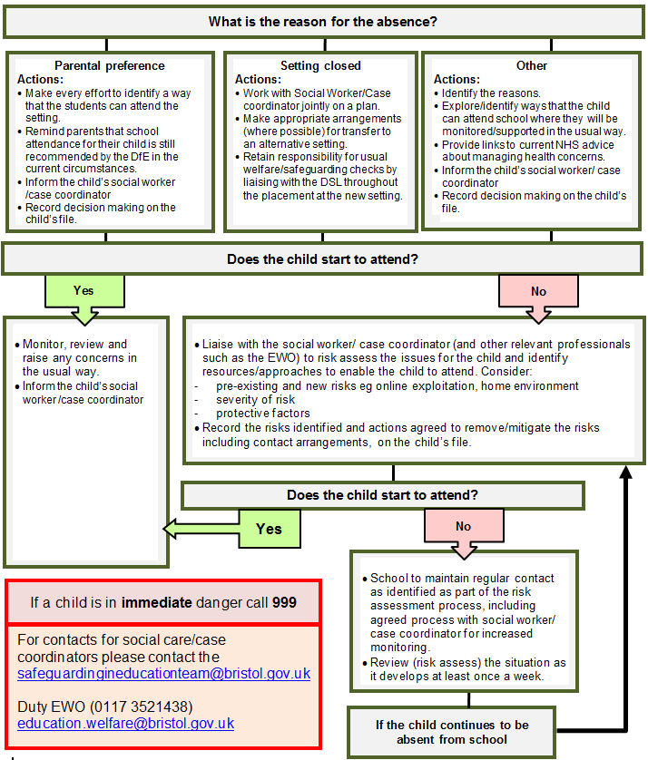

# Appendix C

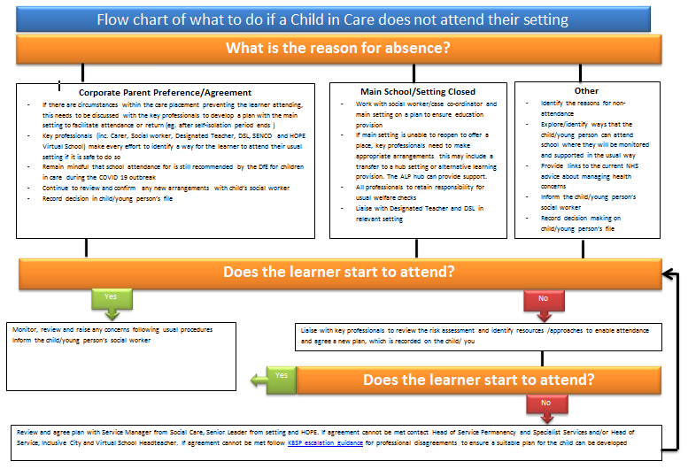

# Appendix D – Resources:

Please see the [Safeguarding in Education Team](https://www.bristollearningcity.com/education/safeguarding-in-education/) web page for a range of resources.

