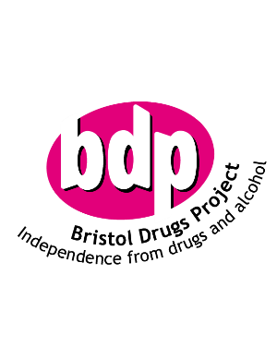

**11 Brunswick Square,**

**Bristol, BS2 8PE**

Registered Charity No: 291714

Registered Company Limited by

Guarantee Number: 1902326

Date 04/11/20

To whom it may concern

**Safeguarding and Safer Recruitment: Letter of Assurance**

In accordance with the requirements of the DfE guidance ‘Keeping Children Safe in Education’. I can confirm that BDP has undertaken all the necessary safeguarding, safer recruitment and vetting and barring checks in line with current legislation and the requirements of the Employment Checks Standards and the Ofsted rules for all its employees. This includes Enhanced DBS Disclosure for eligible roles undertaking Regulated Activity.

As part of our checks and clearances processes; we regularly review our BDP Youth Team on a regular basis to ensure that we maintain safe practicing standards. Part of our measures ensure we review our staff DBS’s every two years and carry out each year safeguarding training , including BDP inhouse from its appointed Safeguarding Lead and two yearly multi agency training from Keeping Bristol Safe .

Should you require further information in regards to the above please do not hesitate to contact me.

Yours sincerely

cid:image001.jpg@01D64EC2.C0E9FB70

Community Services Manager BDP